PR Testing Report:

Accuracy=(true positives+true negatives)/(total positives + total negatives)

Accuracy After Mean Normalization without PCA: 99.7%

Replaced with 0.5 for Nan of Mean normalization and used trainingdata3 where trainingdata3=[X_norm Y];

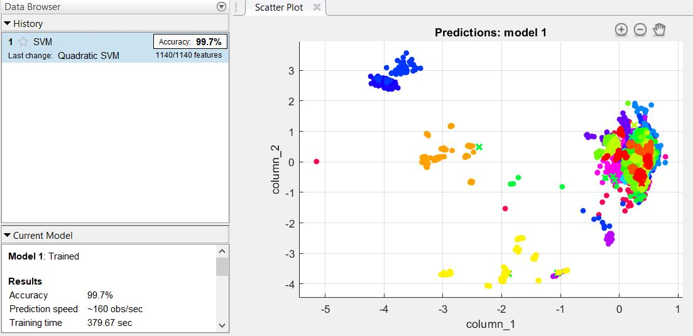

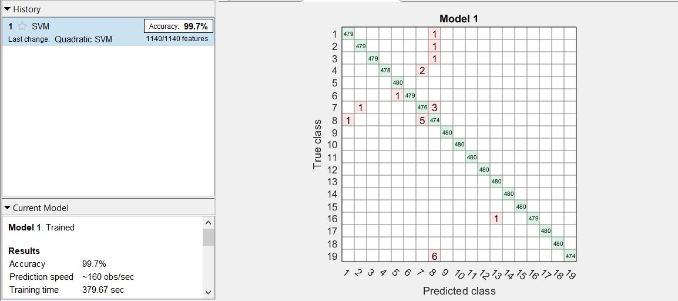

AFTER MEAN NORMALIZATION WITH PCA (SELECTED 30 FEATURES AS Z FOR PCA)

Accuracy obtained= 99.6%

Replaced with 0.5 for Nan of Mean Normalization

Used trainingdata3=[X_norm Y] and also PCA in Classification Learner.

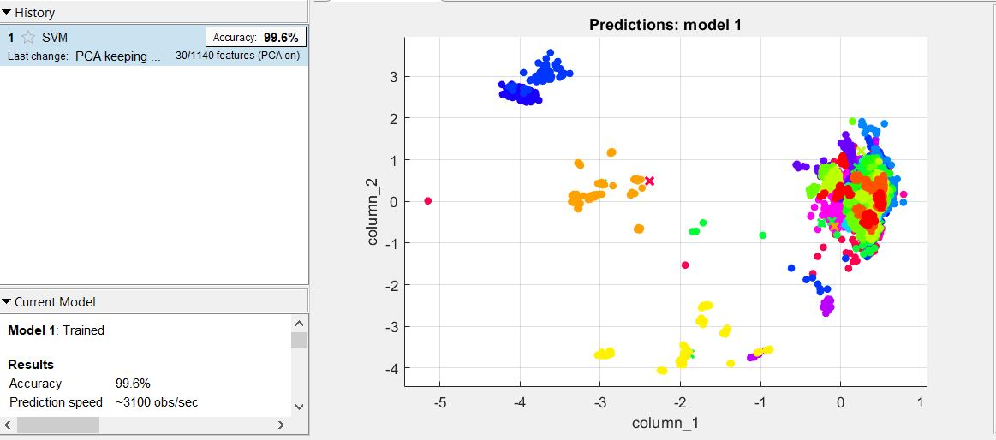

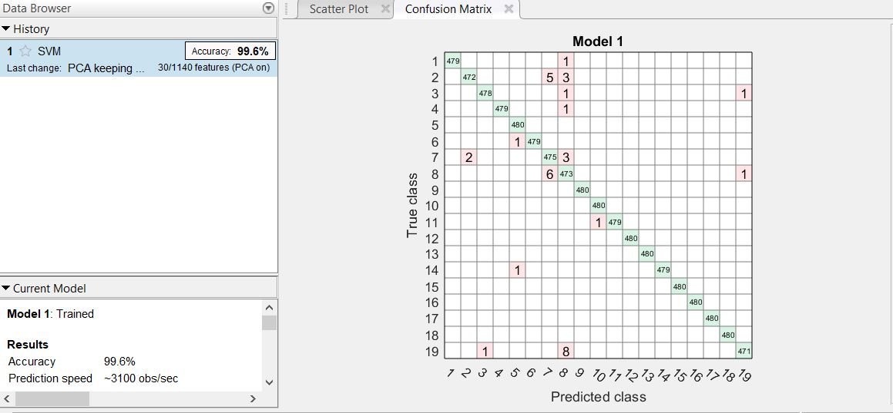

Feature Data without Mean Normalization ( Original Data Matrix):

Without PCA

Accuracy: 99.7%

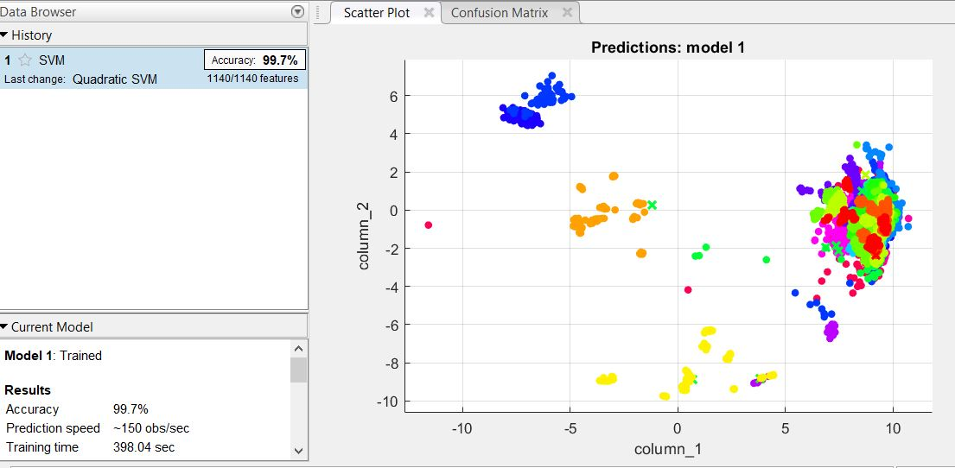

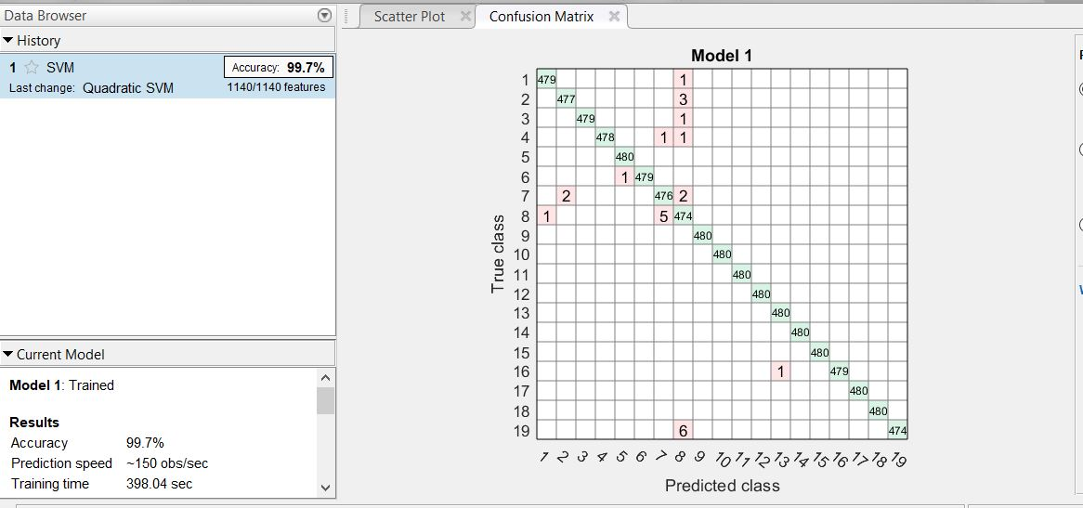

Original Data with PCA:

Accuracy -99%

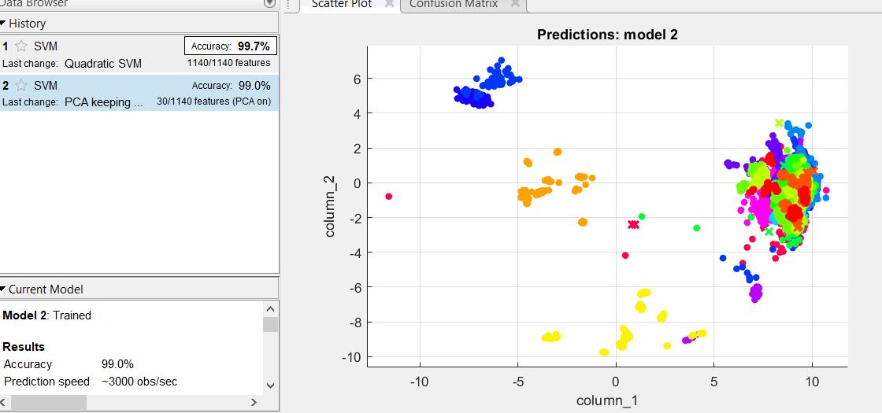

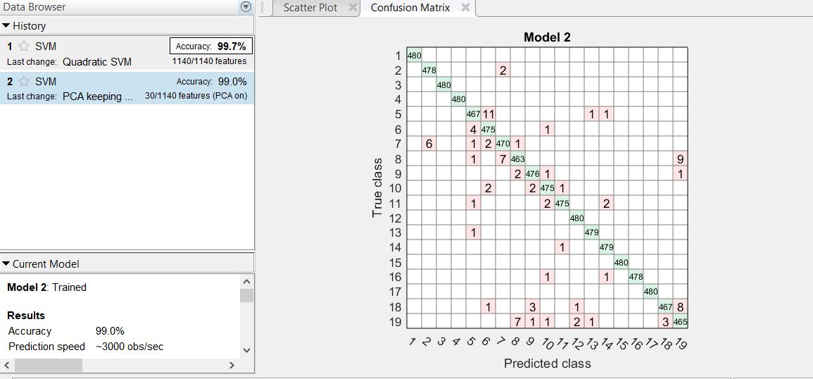

ROC CURVES:

. The ROC curve shows true positive rate versus false positive rate for the currently selected trained classifier. You can select different classes to plot.

The marker on the plot shows the performance of the currently selected classifier. The marker shows the values of the false positive rate (FPR) and the true positive rate (TPR) for the currently selected classifier. For example, a false positive rate (FPR) of 0.2 indicates that the current classifier assigns 20% of the observations incorrectly to the positive class. A true positive rate of 0.9 indicates that the current classifier assigns 90% of the observations correctly to the positive class.

A perfect result with no misclassified points is a right angle to the top left of the plot. A poor result that is no better than random is a line at 45 degrees. The **Area Under Curve** number is a measure of the overall quality of the classifier. Larger **Area Under Curve** values indicate better classifier performance. Compare classes and trained models to see if they perform differently in the ROC curve.

Artificial Neural Networks:

With 10 hidden Layers:

Time=10sec

Original Data-99.89%

Data with Mean Normalization-99.81%

Mean normalization confusion Mat-

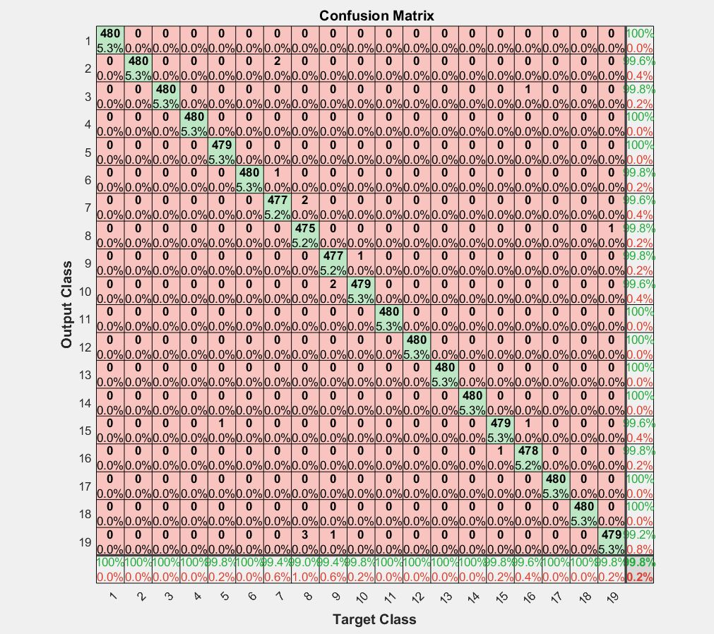

Original Data Confusion Mat

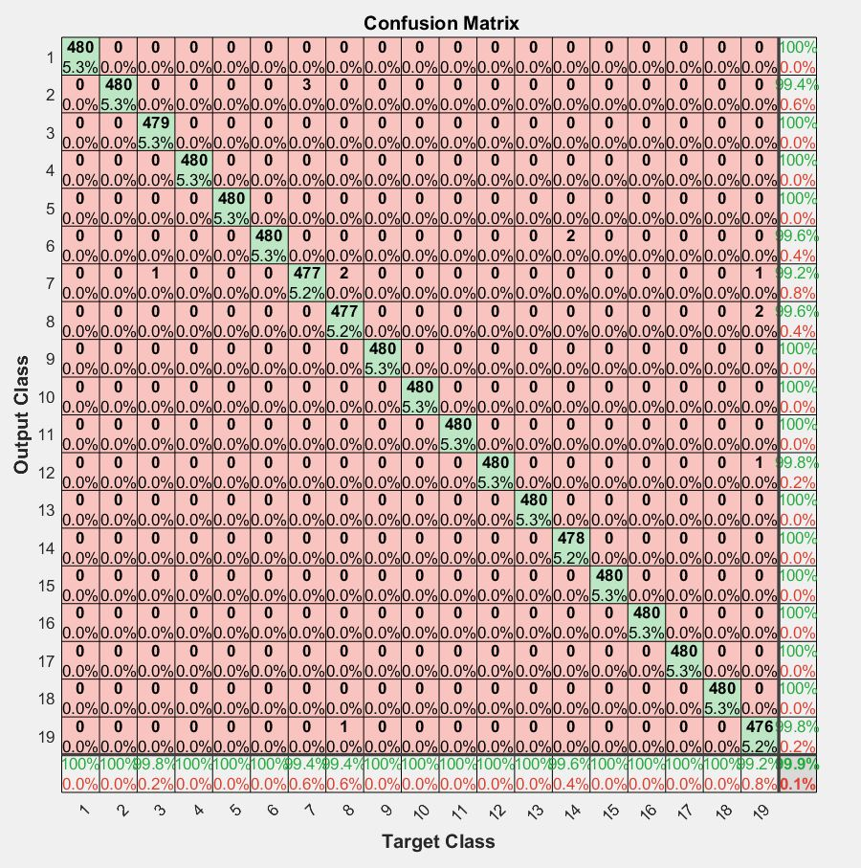

With 20 hidden Layers:

Accuracy=99.97%

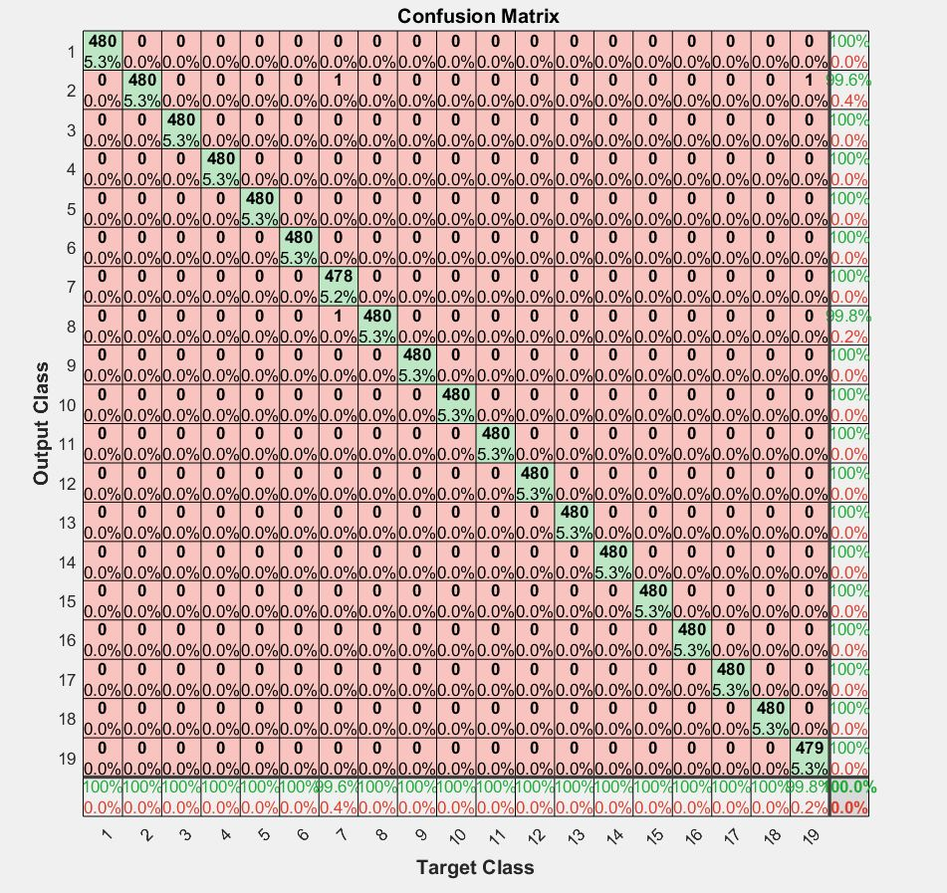

With 30 hidden Layers:

Time=14 sec;

Accuracy=99.97%;

With 40 hidden Layers:

Time=15 sec;

Accuracy=99.98%;

With 5 hidden Layers:

Accuracy=88.87%

An inordinately large number of neurons in the **hidden layers can increase** the **time** it takes to **train** the network. The amount of **training time can increase** to the point that it is impossible to adequately **train** the neural network.

The time taken for training increases with increase in the number of hidden Layers. Though the accuracy increases, it becomes insignificant when time taken to train is taken into account. So, 20 hidden layers are considered.

ROC CURVES FOR 20 HIDDEN LAYERS:

